**Ideation Phase**

**Brainstorm & Idea Prioritization Template**

|  |  |
| --- | --- |
| Date | 05 July 2025 |
| Team ID | LTVIP2025TMID35592 |
| Project Name | EduTutor AI: Personalized Learning With Generative AI And LMS Integration |
| Maximum Marks | 4 Marks |

• **EduTutor AI** is an AI-powered platform for personalized learning with LMS integration.

* Features include adaptive content, AI tutor chatbot, automated lessons/quizzes, and multilingual voice support.
* Teachers get AI analytics, smart grading tools, and LMS syncing.
* Learner engagement boosted through gamification, sentiment tracking, and parent dashboards.
* Feature priorities ranked using RICE scoring for maximum impact.

Referene:

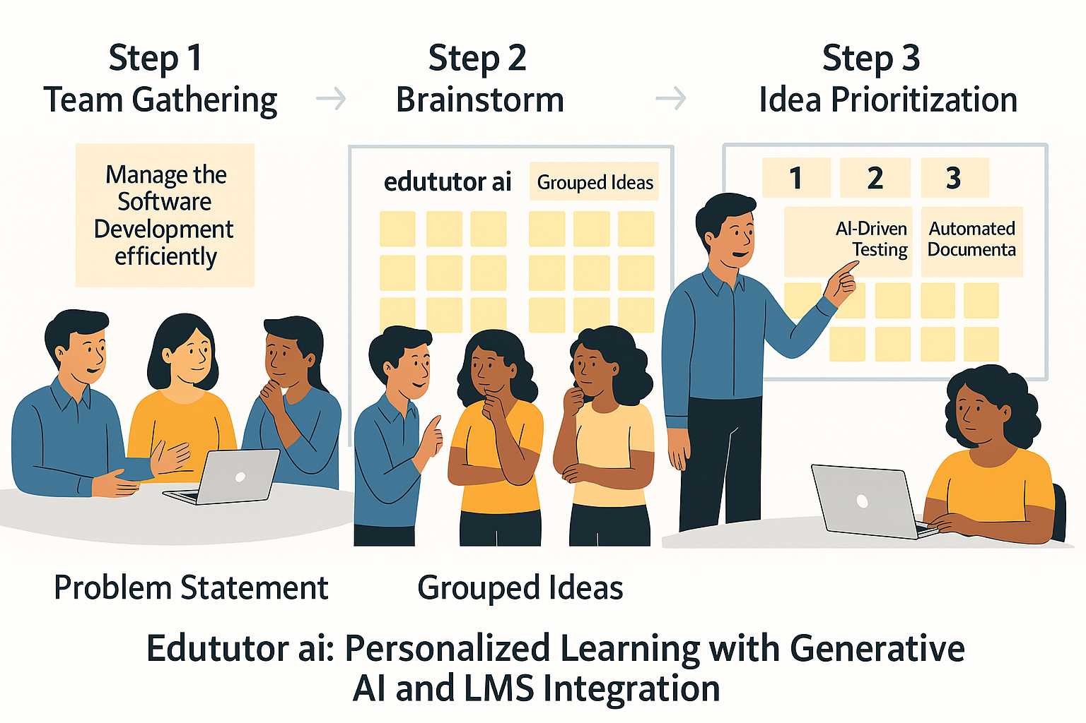

## 🎯 Efficient Learning Experience Management

* To foster productivity and innovation in AI-powered personalized education, a structured process has been designed:

### 👥 Step 1: Team Gathering

* Bringing together educators, AI experts, curriculum designers, and LMS engineers is essential. Team members collaboratively define goals, align on learner needs, and create a foundation for personalized and intelligent learning.

### 💡 Step 2: Brainstorming Session

* With alignment in place, a brainstorming session encourages diverse and creative ideas. No concept is off-limits—this phase thrives on innovation in teaching methods, AI applications, and learner engagement strategies.

### 📌 Step 3: Idea Prioritization

* Ideas are categorized and assessed based on feasibility, educational impact, and alignment with learner success. High-priority ideas identified in this case include:  
  • Personalized AI Tutoring  
  • Real-Time Adaptive Learning Paths  
  • Integrated LMS Analytics and Automation Tools

